Week 4(ASP CORE API)

Swagger output:

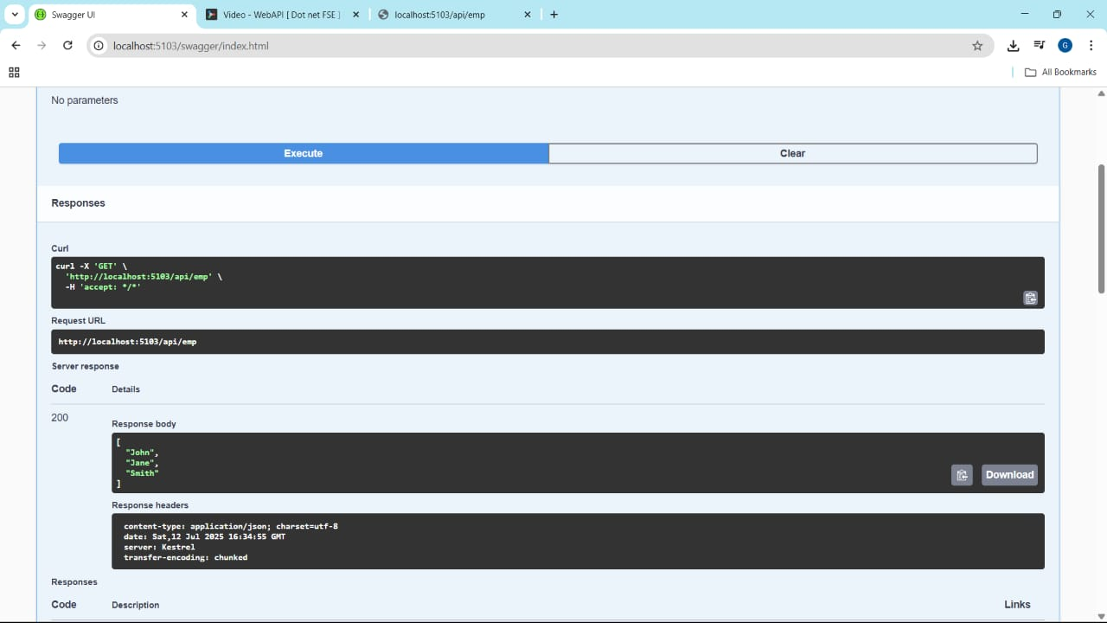

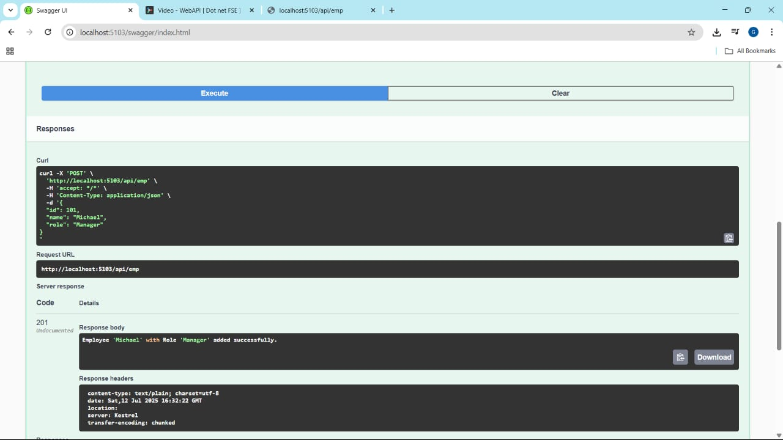

**Program:**

using AspCoreApi.Filter;

var builder = WebApplication.CreateBuilder(args);

builder.Services.AddControllers();

builder.Services.AddEndpointsApiExplorer();

builder.Services.AddSwaggerGen();

var app = builder.Build();

app.UseHttpsRedirection();

app.UseSwagger();

app.UseSwaggerUI(c =>

{

c.SwaggerEndpoint("/swagger/v1/swagger.json", "My API V1");

});

app.UseAuthorization();

app.MapControllers();

app.Run();

**webAPI:**

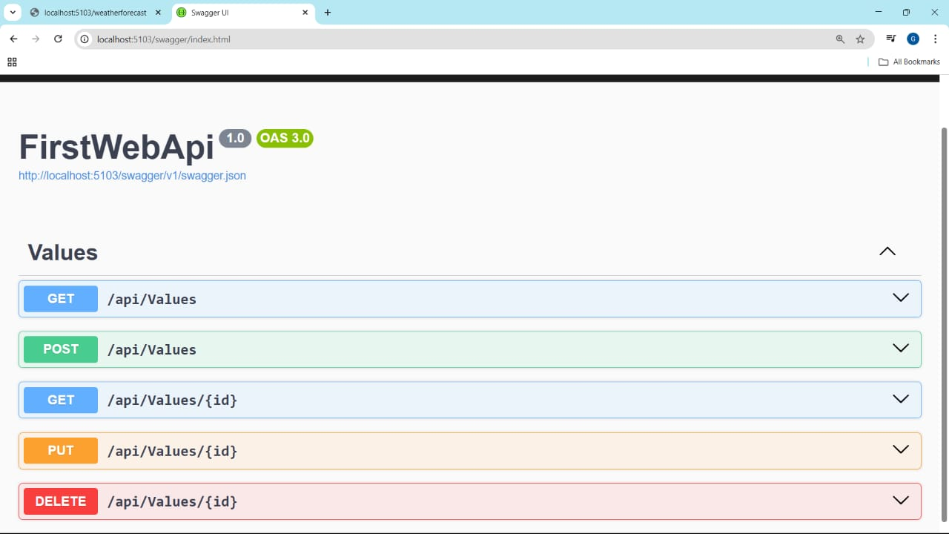

**Postman(get):**

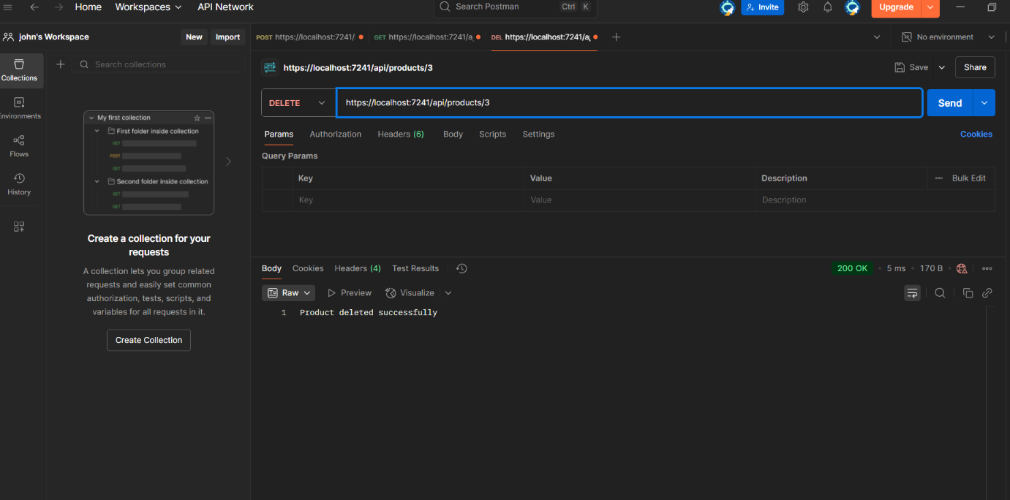

**Postman(delete):**



**Postman(post):**

